Title, only the first letter upper case: Maximum of 2 lines, aligned left, Arial 18pt

Principal Author¹, Second Author², Third Author³

¹First Institution, City, State
²Second Institution, City, State
³Third Institution, City, State

ABSTRACT: The abstract of the full paper must use Arial 9pt, be no more than 300 words in length, have paragraph/s justified, and use no first line indents. The abstract should briefly summarize the paper stating its objectives, methodology and achieved outcomes. This abstract might appear in a Conference Abstracts brochure at the conference.

KEYWORDS: May include up to five key words or terms, separated by semicolons.

INTRODUCTION
Each submitted paper will be blind refereed and, when accepted, published in the conference proceedings. Papers submitted must contain all required information about their authors, though that information will be removed before sending the paper for review. Authors are fully responsible for their papers, which should not have been published elsewhere. Authors must have taken necessary steps to obtain permission to use any material that might be protected by copyright. Please note that on delivery of the manuscript, the author transfers the copyright on the publication to the publisher, with no need of further transfer.

- LAYOUT

1.1. Length of paper
Full Papers are limited to a minimum of 3000 words and maximum of 6000 words or a total of 8 pages maximum, including abstract, references, endnotes, figures and captions. File size is strictly limited to 5mb. Authors should optimize graphics (i.e. size and resolution appropriate for this format). Graphic resolution should not be any lower that 150 dpi for print quality. Separate images may be requested for proceedings.

1.2. Margins and organization of the paper
Papers should have 1.25" margin on the top, 1” margin at the bottom, 1.25” margin on the right, and 1.25" margin on the left. Please format body of paper in a one 6-inch column format. No headers, footers or footnotes are allowed. The paper should be organized in chapters and sections consecutively numbered using Arabic numerals and decimals. Both chapters and sections (subsections) should be preceded with single blank lines.

1.3. Font size and format
Text should be written using Arial typeface and sizes as used in this document. Should you need to emphasize some words, use italics rather than underline or bold styles. Do not use upper case other than for first letter of the title, names, units of measurement (if appropriate) and entire chapter headings.

1.4. Paragraph format
Paragraphs immediately following their headings must be justified on both sides with no indents for first lines. The document should use single-line spacing throughout.
1.5. Quotations
Quotations shorter than 15 words “should be given within the body of text and enclosed in quotation marks”.
Where a quotation is longer than 15 words, it should be given its own paragraph, indented by 0.4 inch left and right and justified on both sides. Quotation marks should not open or close such quotations. Indented quotations should be in Arial 8pt. No blank lines should precede or follow the paragraph unless a section break occurs.

1.6. Figures: drawings and photographs
Illustrations should not exceed 50% of the entire paper content and should be located close to their corresponding text. All supplied images should be formatted as jpg. Illustrations should be clear and legible when printed.

All drawings and photographs must carry numbers in the text (e.g. Fig. 1) and captions. Captions should be complete enough to allow appreciation of the illustration without referring to the text. Lettering of the caption should be Arial 8pt. In addition, captions should cite source of the image, other than the author’s own archive should be given directly under the image using the recommended referencing style (see 1.6 above) and the font size to be Arial 8pt. Single blank lines should precede and follow the image.
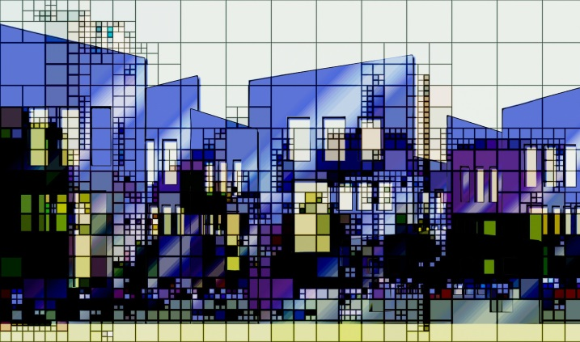

Figure 1: Images should be aligned left on the page. Source: (Author 2005)

1.7. Tables
All tables should be consecutively numbered and adequately captioned. Their placement should be as close as practical to the relevant part of the text (Table 1). Those tables not assembled by the author/s should have their source given immediately under the table (see 1.7 above). Use single blank lines before and after the table.

Table 1: Tables should be aligned left on the page. Source: (Ching 1999)
Glazing type |  | U-value [W/m²K]
 |  | out | in
Clear+clear |  | 0,42-0,61 | 169-192
Clear+low-e |  | 0.23-0.52 | 133-157
Clear+tinted | grey | 0,49-0,60 | 74-152
 | bronze | 0,49-0,60 | 76-152
 | blue | 0,49-0,58 | 120-154
Clear+coated | silver | 0,39-0,48 | 36-59
 | blue | 0,42-0,46 | 58-73
 | copper | 0,29-0,30 | 44

The committee recommends the use of the same type face for the table contents as for the body of the text.

1.8. Equations
Equations should begin from the left margin, with one blank line above and one below to separate them from text. Equations should be numbered consecutively with the number in brackets justified on the right hand margin. Symbols should be defined upon first use.

1.9. References
Reference to sources listed at the end of the paper should be made by name of the author and year of the publication given in parenthesis (Author 2005). Quotations alone should include the page number after comma (Author 2005, 22). Should there be no author given in the source, the first words of the title are sufficient to identify the source in the list and should appear in italics (Title of the publication 2005). Footnotes may not be used.

If explanatory notes are necessary to the paper, endnotes may be used. Endnotes must be listed numerically and consecutively, both in the essay and in the Endnote citation. Endnote numbers must be superscripted following almost any punctuation mark in the text. All endnotes should appear on the final page of the document (after the References).

1.10. Units
The committee recommends use of SI units of measurement. Other units (e.g. American) are permissible only following the SI units and then must be given in parentheses, for instance, 404kPa (58.6psi) or 63.7m² (685.7ft²).

2.0. EDITORIAL CHANGES
If a paper has not met the requirements for submission, the file will not be processed for review and the author will be requested to resubmit. If everything is in order, the author will receive a confirmation that the paper is under review.

2.1. Units
The editor reserves the right to adjust the format of the submitted text as required in the publishing process.

CONCLUSION
Each paper must be submitted as a “.doc” file through the OCS conference website no later than 23:59 CEST on February 17, 2020. Once the paper has been accepted, authors should register for inclusion in the published proceedings. If accepted, the final version of the paper must be sent by April 27, 2020 23:59 CEST.

The access to the OCS conference website will be available on the event website: https://www.eaae-arcc-ic.upv.es/instructions-for-authors/

ACKNOWLEDGEMENTS
This document was originally adopted from ANZAScA (Australia and New Zealand Architectural Science Association) and used in prior ARCC Spring Research Conferences. The contribution of the previous ARCC conference organizers and committees is hereby gratefully acknowledged.

REFERENCES
All sources referred to in the text should be listed in alphabetical order, following the Chicago Manual Style (CMS) format. Each reference in the list of references must include author/s name and initial/s, year of publication, title (in italics), place of publication, and publisher.

Author, I., Author, I. and Author, I. 2005. Publication title. Place: Publisher.

ENDNOTES
¹Explanatory notes may be used as endnotes, following the Chicago Manual Style (CMS) format. For your reference: http://www.chicagomanualofstyle.org/tools_citationguide.html

